

BENV0096: MSc ESDA Dissertation

“Developing a method to estimate the split of gas consumption into space and water heating”

by

HZYC1

29 August 2024

**Paper submitted in part fulfilment of the**

**Degree of Master of Energy Systems and Data Analytics**

**Energy Institute**

**University College London**

Word count: 9,824

**UCL** Energy Institute



**Coursework Submission**

**Title** Developing a method to estimate the split of gas consumption into

space and water heating

**Student name** HZYC1

**Student number (This can be found on your student identity card)** 19078901

**Module title** MSc ESDA Dissertation

**Module Code** BENV0096

**Submitted to** UCL Energy Institute, Bartlett School of Energy, Environment and Resources

**Statement of authorship:**

I certify that the attached coursework exercise has been completed by me and that each and every quotation, diagram or other piece of exposition which is copied from or based upon the work of other has its source clearly acknowledged in the text at the place where it appears; all field work and/or laboratory work has been carried out by me with no more assistance from the members of the department than has been specified; and all additional assistance which I have received is indicated and referenced in the report .

**Signature of Student Date Submitted: 29/08/2024**



**You are reminded that the normal ESDA regulations apply when applying penalties for late submission – see the ESDA General Moodle page for details.**

Contents

List of Figures 4

List of Tables 4

Introduction 6

Literature review 8

Exploratory Data Analysis (EDA) 11

Data description 11

Data cleaning and Manipulation 11

Gas problem 13

Identifying heating periods 15

Methodology 19

Heuristic method Ratio and proportions method 19

Linear Regression models 23

Deep learning models 23

Neural Network 24

Artificial Neural Network 24

Deep Neural Network 25

Long Short-Term Memory 25

Evaluation metrics 26

Model evaluation and Results 29

Model Evaluation of the heuristic methods 29

Results of the heuristic models 31

Model Evaluation of the liner regression and Deep learning 36

Results of linear regression and neural network models 38

Linear regression 38

Artificial neural network ANN 39

Model evaluation of Hourly vs daily 42

Results of daily ANN model 44

Conclusion and Future works 46

References 48

Appendix 51

# List of Figures

Figure 1:UK emissions in 2019 (DBEIS, 2021). 6

Figure 2: Gas Consumption 14

Figure 3:Gas consumption simple threshold 14

Figure 4:Gas consumption interquartile threshold 14

Figure 5: Indoor and Outdoor temperature 15

Figure 6: Heating Period 16

Figure 7: Bathroom humidity and moving threshold over 1 month 17

Figure 8:Bathroom humidity moving threshold 17

Figure 9: Showering periods 18

Figure 10:Flow Chart 18

Figure 11: ANN model diagram by Andrieu, M. 2019 25

Figure 12: LSTM model by (Vidhya., 2022) 26

Figure 13: Method 1 predictions 31

Figure 14: Method 2 total prediction 32

Figure 15: Method 2 SH and DWH predictions 33

Figure 16: Method 3 predictions 34

Figure 17: Method 3 Interpolated predictions 34

Figure 18: plots of evaluation metrics for table 6 36

Figure 19: Linear regression prediction 38

Figure 20: Epoch of ANN for SH, DWH and total 39

Figure 21:ANN hourly total prediction on training data 40

Figure 22:ANN hourly total prediction 40

Figure 23: ANN hourly SH prediction 41

Figure 24: ANN hourly DWH prediction 42

Figure 25: ANN daily epoch 43

Figure 26: ANN daily prediction total 44

Figure 27: ANN daily prediction SH 44

Figure 28: ANN daily prediction DWH 45

# List of Tables

Table 1: Data types 12

Table 2: missing values 12

Table 3:Missing values aggregated 13

Table 4: Evaluation criteria of MAPE (Lewis., 1982) 28

Table 5: Evaluation metrics for heuristic methods 29

Table 6: Evaluation metrics of linear regression and deep learning 36

Table 7: Evaluation metrics of hourly and daily 43

**Acknowledgments**

I would like to express my deepest gratitude to my supervisor, Dr. Frances Hollick, for her invaluable support, guidance, and encouragement throughout the course of this dissertation project. Her insightful suggestions and expert advice were instrumental in shaping the direction and success of this work. I am sincerely thankful for her unwavering patience and commitment, which provided me with the confidence and clarity needed to complete this research

**Abstract**

Accurately predicting gas consumption for residential buildings is crucial for the effective integration of renewable energy and advanced technologies, such as the transition from traditional boilers to heat pumps. This study investigates various predictive models, including heuristic approaches, linear regression, and deep learning techniques, to estimate the allocation of gas consumption between space heating and water heating. Among these methods, the deep learning model, specifically the artificial neural network, demonstrated superior performance. The artificial neural network model achieved an R² value ranging from 0.27 to 0.51 when applied to hourly gas consumption data and an improved R² value of 0.63 to 0.79 with daily aggregated data. These findings suggest that deep learning models are more effective in capturing the complexities of residential gas consumption patterns, highlighting their potential utility in optimizing energy usage and supporting the deployment of energy-efficient technologies.

# Introduction

As of 2023, the UK has made significant improvements in reducing its emissions, with a goal of achieving net zero carbon by 2050. The UK’s national net territorial greenhouse gas emissions have decreased to 384.2 MtCO2e, marking a 52.7% reduction since 1990. This substantial decline is primarily due to a combination of reduced gas demand and increased electricity imports (DESNZ, 2024)

An examination of the UK's emissions, as seen in Figure 1, shows that buildings constitute a major source of greenhouse gases, contributing to 30% of the total 454.8 MtCO2e recorded in 2019 (DBEIS, 2021). Within this sector, heating alone accounts for 23% of emissions, with residential heating making up 17%. These figures emphasize the pressing need to address household energy consumption, which largely revolves around the use of electric appliances, space heating (SH), and domestic water heating systems (DWH). However, efforts to mitigate these emissions have shown progress, as emissions from buildings and product usage have decreased, now representing 20.2% of the overall emissions (DESNZ, 2024).

Figure 1:UK emissions in 2019 (DBEIS, 2021).

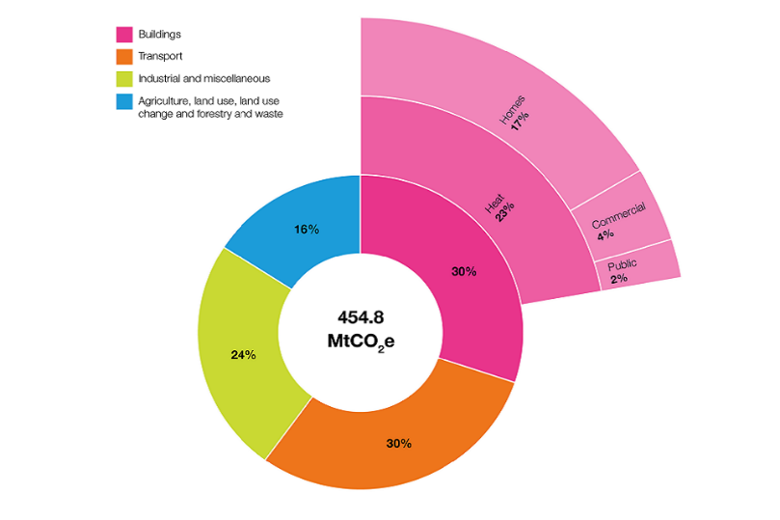

The UK's strategy for monitoring household emissions includes the adoption of smart meter technology. Since their introduction in 2008, approximately 33.9 million smart meters have been installed in UK homes by 2023 (uSwitch, 2023). These devices offer real-time data on electricity and gas consumption, contrasting with traditional meters that require manual readings and only provide periodic data. The real-time insights from smart meters empower consumers to make informed decisions about energy usage, contributing to energy conservation and cost management. Moreover, smart meters enhance billing accuracy, enable dynamic pricing, and support the integration of renewable energy sources, playing a crucial role in modernizing the energy infrastructure.

Despite their benefits, current smart meters in the UK have limitations, as they do not distinguish between gas used for SH and DWH (uSwitch, 2023). This gap presents an opportunity for further innovation in energy monitoring and management in the pursuit of sustainable energy solutions. The distinction between SH and DWH systems is vital, as this differentiation not only aids in the precise sizing and selection of heating systems but also facilitates the efficient integration of low-carbon energy sources and heating systems such as heat pumps, biomass, and solar thermal energy into household energy frameworks. By analysing the unique demands of SH and DWH, energy systems can be tailored to optimize the use of the most suitable and efficient low-carbon technologies.

For instance, the replacement of gas boilers with heat pumps is one of the UK's strategies to achieve net zero (GOV.UK, 2023a). The data can help address the base load requirements of SH, thereby ensuring sustainable, consistent, and reliable solutions for both SH and DWH. Moreover, solar thermal systems are particularly advantageous for meeting DWH needs, especially during periods of high solar availability. By prioritizing DWH in solar thermal designs, excess heat can be effectively utilized, thereby decreasing dependency on conventional energy sources such as natural gas used for SH and water heating in domestic homes (GOV.UK, 2023b).

Furthermore, district heating systems exemplify the benefits of centralized energy production and distribution, especially for apartment complexes or housing estates where many people live in close proximity. By producing thermal energy at a central plant and distributing it through a network of insulated pipes, district heating enhances energy efficiency, reduces heat losses, and facilitates the integration of various energy sources such as natural gas, biomass, geothermal energy, or waste heat from industrial processes. This centralization not only improves urban air quality by concentrating emissions control but also supports the sustainability of urban infrastructure by providing reliable and consistent heating. Additionally, heat networks allow for the cost-effective delivery of low-carbon heat, which is crucial for reducing carbon emissions from heating, and can also harness waste heat from industrial processes or natural sources, further boosting their environmental and economic benefits. The adaptability of these networks to connect new demand and heat sources makes them an essential component of future clean energy infrastructure, particularly in high-density urban areas (DBEIS, 2018).

The integration of smart technologies, such as smart meters play a crucial role in not only monitoring and managing energy consumption but also the provision of detailed energy usage data can shape consumer behaviour toward more sustainable practices As the UK aims to achieve its net-zero carbon goals by 2050, the precise energy data and targeted interventions is incredibly important.

By understanding the specific demands for SH and DWH helps to create accurate predictions and energy profiles, making it easier to integrate renewable energy and technology such as heat pumps into buildings efficiently. These insights are crucial for shaping future energy policies and designing systems that make the most of renewable resources. This approach is essential for transitioning to a low-carbon economy.

# Literature review

The issue of distinguishing between SH and DWH from total gas consumption measurements in buildings has been addressed by numerous research studies, each proposing a unique methodology.

One of the first studies to tackle this problem is by Bacher et al. (2016) uses a non-parametric method to separate SH and DWH. This method uses a statistical time series approach where SH demand is assumed to be smooth with small changes and spikes in demand. In contrast, DWH demand is characterised by an intense and sudden spike in demand profile. The methodology employed was kernel smoothing, which was applied to the entire dataset to estimate SH. Values significantly above the smoothed estimate were identified as DWH. This method reduces the need for additional sensors and mitigates the impact of DWH spikes on SH estimates, allowing for more accurate differentiation between the two. However, there are a few limitations to the method. Firstly, there is a lack of validation, which makes the method's accuracy uncertain. Secondly, the method relies on manual tuning, which limits its practical ability when employed with a large data set spanning over a year and over multiple different households.

Similarly, another method that assumes smooth SH demands, as proposed by Leiria et al. (2023) employs low-resolution smart meter data to estimate SH and DWH energy demands in residential buildings. The method employed a combination of maximum peaks, with Kalman filtering and support vector regression (SVR). The Maximum Peaks approach is used to identify significant events in time series data by detecting sudden and intense spikes, which are characteristic of DWH events. This approach is the most effective for detecting DWH gas usage. A combination of SVR, which models the relationship between input and output variables, is also employed. The combination of features and the output variable, together with Kalman filtering, which estimates unknown variables by using a series of measurements observed over time, refining predictions to account for noise and inaccuracies in the data, was found to be the most effective for estimating SH and DWH separately.

However, this methodology shares the same limitation as the method by Bacher et al. (2016) which assumes SH demands are smooth. This assumption may not be valid in buildings with complex heating patterns. The reliance on smooth SH demand assumptions and simplistic identification techniques can limit its robustness, particularly in buildings with complex heating patterns or a high proportion of missing data. Additionally, the assumption that SH operates continuously throughout the day does not always reflect actual usage patterns, further reducing its accuracy and adaptability.

Pomianowska et al. (2019) introduced a simple methodology to estimate the mean hourly and daily profiles of DWH demand from hourly total heating readings. This approach involves disaggregating smart meter data on the assumption that summer heat demand is equivalent to do DWH usage. It offers valuable insights into customers' DWH habits by defining average load profiles, which can be particularly useful for newly built households with a high DWH usage share.

Although this method is straightforward and readily implementable, it assumes that there is no SH demand during the summer, which may not always be accurate. This can reduce its effectiveness in certain climates or households with different heating habits. The method demonstrated that it performs well when the DWH usage during the summer is at least equivalent to the SH demand. However, for large-scale analysis, this method is not suitable, as it is not feasible to assume SH demand status during other seasons, such as autumn.

A similar methodology to that introduced by Pomianowska et al. (2019) is the one by Alzaatreh et al. (2019), which involves the disaggregation of SH and DWH usage from high-resolution gas metering data using pattern recognition techniques. By analysing the dynamic patterns of gas consumption and employing Dynamic Time Warping as a similarity metric, the method can effectively filter out non-heating usage data.

This methodology employs a dataset comprising gas meter readings taken at one-minute intervals. It has been tested on two occupied houses and enables the detection of activity windows, the application of a smoothing filter and the utilisation of Dynamic Time Warping for the matching of heating patterns.

However, the method's reliance on high-frequency data presents challenges for broader application, and it assumes consistent heating patterns, which may not be representative of all households. Furthermore, the usage of high-resolution data proved to be a disadvantage when attempting to apply this method across multiple months.

In a similar approach, Ivanko et al. (2020) proposed a methodology that employs an energy signature curve and singular spectrum analysis to decompose total heat use into SH and DWH usage. This approach assumes that outdoor temperature predominantly influences SH usage, while DWH demand remains relatively constant irrespective of weather conditions. The ESC model derives the profile of SH heat use by correlating it with variations in outdoor temperature, while residuals are employed to estimate DWH use.

Although the method demonstrates high accuracy for SH modelling, with a coefficient of determination (R²) of 0.97, it assumes that DWH is not influenced by outdoor temperature and relies on high-resolution data, which may not be applicable in all scenarios, particularly in different buildings or climates. Furthermore, the accuracy of the SH model is contingent upon the accurate identification of the change point temperature, which may vary depending on the insulation characteristics of the building in question and the season.

In contrast, Li and Yao (2020) put forth a machine learning-based methodology for forecasting residential annual SH and cooling loads, considering occupant behaviour. The study employs five machine-learning models, namely Gaussian radial basis function, support vector regression (SVR), polynomial kernel SVR, linear regression and artificial neural networks.

The Gaussian model was identified as the most effective, with the shortest computational time. However, the other models, particularly artificial neural network and polynomial kernel SVR, despite requiring significantly longer computation times, still provided high accuracy. However, the approach relies on high-resolution data and accurate modelling of occupant behaviour, which can vary widely and influence energy consumption patterns. The study acknowledges that integrating diverse occupant behaviours as predictor variables can enhance model accuracy, but this approach also increases the complexity of data collection and model training.

Maltais and Gosselin (2021) investigated the potential for predicting DWH consumption using artificial neural networks in both single units and larger residential buildings. The study demonstrated high accuracy for larger systems, achieving a coefficient of determination (R²) of 0.88 for the entire building. However, the accuracy varied for smaller individual buildings, reflecting the sporadic nature of DWH usage in individual units. The necessity for extensive historical data and the importance of carefully optimising neural network architectures demonstrate the complexity of implementing this method across diverse settings.

In another deep learning study, Heidari and Khovalyg (2020) developed a method of predicting short-term energy consumption in solar-assisted water heating systems. The method uses combination of Long-Short Term Memory neural networks with attention mechanisms and time-series decomposition resulted in a notable enhancement in prediction accuracy, with a 41% reduction in Mean Absolute Error and a 65% reduction in Mean Squared Error compared to a baseline feed-forward neural network model. This illustrates the superiority of the proposed methodology. However, the reliance on high-resolution data and complex training may restrict the practical applicability of the methodology, and further validation is required to ensure its generalisability across different systems and conditions.

By synthesizing insights from these studies, my project will contribute a novel methodology for estimating the split of gas consumption into SH and DWH that is accurate, scalable, and applicable to a wide range of real-world conditions. This will not only enhance energy management strategies but also facilitate more effective implementation of energy-saving measures in residential buildings.

# Exploratory Data Analysis

In this section of the project, the exploratory data analysis is conducted to identify and address any issues with the dataset, ensuring that it is properly cleaned and prepared. This step is crucial for detecting outliers, handling missing values, and transforming the data to optimize the performance of predictive models for SH and DWH energy consumption.

## Data description

The data used in this project was collected from 30 different households located in two neighbouring towns in northwest England. It consists of smart meter data that records gas consumption (in cubic meters) and electricity consumption (in kilowatt-hours) for the entire dwelling. Additionally, indoor air temperature (in degrees Celsius) and relative humidity (in percentage) were measured in individual rooms. These measurements were taken at 30-minute intervals. All 30 households involved in the study use combi boilers, ensuring there is no delay between gas usage and either SH or DWH.

Outdoor weather data, measured at a single location within 6 km of all the homes, is also available. This weather data includes wind direction, wind speed, rainfall, air temperature, relative humidity, air pressure, and vertical global solar irradiance, recorded at 10-minute intervals. The data collection period varies among households, starting as early as 2019 and continuing through to March 2021 for all households.

## Data cleaning and Manipulation

for this project data from 30 households were combined to generate an average dataset for all households, as demonstrated in the Table 1. This method was necessary due to the varying periods over which data were started to be collected for each household which leads to higher number of missing data, as shown in Table 2. The highest number of missing data points, 17,216, was recorded for backroom humidity, which was not consistently present across all households. By aggregating data from all 30 households and calculating the mean for rooms related to SH and DWH as seen in Table 2, missing data were reduced without the need to remove rows with the missing values, thereby preserving the dataset size and reducing potential model error.

Table 1: Data types

Table 2: missing values

Due to the data collected from different households the variable names for indoor temperature and humidity of individual rooms also differ therefor to simplify the data rooms that require SH are identified and mean are found, the only rooms that require DWH are the kitchen and bathrooms however the kitchen is not used to find the mean as the change in temperature and humidity are not often caused by SH rather the use of cooking there for it is not used to prevent low precision during predictions.

Once all the fields are combined into SH fields and DWH fields the missing values have been reduced because of the overlapping with NA and whilst finding mean and skipping columns with NA. Missing values for the combined data can be seen in Table 3

Table 3:Missing values aggregated

### Gas problem

One of the problems when combining gas consumption to find mean is the peaks as seen in Figure 2 where gas consumption goes above a value of above 5 m3 , these peaks will cause errors during prediction there for to mitigate this and prevent any anomalies the method is to use a threshold where any values above 3 m3 are removed only keeping anything below however this method requires tuning but anomalies can still occur as seen in Figure 3, another method is to use a Interquartile Range where only the combined gas data between quantile of 0.01 to 0.99 are kept therefore removing the rows with anomalies peaks as seen in Figure 4

.

Figure 2: Gas Consumption

Figure 3:Gas consumption simple threshold

Figure 4:Gas consumption interquartile threshold

### Identifying heating periods

The data used does not distinguish between gas used for SH and DWH, making it crucial to identify periods of SH and DWH separately. This distinction is particularly important in the context of achieving net zero goals, where understanding heating usage patterns can reveal how and when gas is being used. According to the net zero plan where heat pumps are expected to replace gas boilers for all homes by 2050 (GOV.UK., 2023a), it will be essential to identify the times when SH and DWH are needed. This will allow for the estimation of peak electricity usage, which in turn will enable energy providers to effectively manage electricity demand and optimize grid performance to ensure reliable energy supply during peak periods.

One way to identify between SH and DWH periods is to use indoor temperature where when indoor temperature drops below 18 degrees Celsius which according to Umishio et al. (2024) and World Health Organization (2018) is the temperature where individuals start to feel cold. The data then it is label as DWH and when above its label as space and water heating (SH+DWH), this methods purpose is based on a similar method as one used in paper mentioned by Pomianowska et al. (2019), this method applied relies on the indoor temperature which as seen in Figure 5 rarely drops below 18 degrees and even if threshold is above 18 degrees it would be hard to tell if indoor temperature is due to the rise in outdoor temperature.

Figure 5: Indoor and Outdoor temperature

Another method which uses the assumptions for external temperature and human behaviour, this method is based on the one used in the paper by Ivanko et al. (2021). this approach uses a 15-degree Celsius threshold for outdoor temperature to estimate when SH is needed, as shown in Figure 6. However, this method is not very accurate because it relies on outdoor temperature rather than indoor temperature. Outdoor conditions do not directly reflect the thermal comfort inside a home. Indoor temperatures can remain stable due to factors like good insulation, which prevents heat loss, and the presence of occupants, whose body heat can raise indoor temperature slightly. Additionally, thermostats are often set to maintain a specific indoor temperature, activating the heating system only when temperatures fall below that threshold. For example, as shown in Figure 5, the indoor temperature rarely drops below 18 degrees Celsius which is the temperature where individuals start to feel cold (World Health Organization, 2018). This stability suggests effective insulation and thermostat settings above 18 degrees Celsius, which ensure the heating system keeps homes warm. Therefore, using outdoor temperature alone can lead to overestimating or underestimating the need for heating, making it a less reliable predictor of actual heating requirements.

Figure 6: Heating Period

And finally, a method using bathroom humidity, because since the bathroom only uses gas to heat water instead of SH we can determine when the shower is being used meaning a rise in humidity. The methods used previously cannot be use here because there is no constant threshold however a moving threshold can be used inspired by the method used in the paper by Leiria et al. (2023), The Figure 7 shows how bathroom humidity changes over the period of 1 year and figure 8 gives a more in depth view of how humidity and threshold overlaps to estimate shower time where when humidity is higher than threshold then it is labelled as shower on period which means gas is being consumed to heat water as seen in Figure 9.

Figure 7: Bathroom humidity and moving threshold over 1 month

Figure 8:Bathroom humidity moving threshold

Figure 9: Showering periods

The methods implemented to identify the heating periods are illustrated in Figure 9, which compares three different approaches. Ultimately, the moving threshold method was chosen, as it provides the most detailed view of when DWH and space SH are being used. This method allows for a more accurate distinction between the two heating types, offering valuable insights into the specific times and conditions under which each is utilized.

Figure 10:Flow Chart

# Methodology

This study will look at three different styles of methods mainly the Heuristic methods, linear regression and neural networking. All three methods use the data that have been aggregated to hourly data from half hourly to reduce its size and computation time, all method are implemented on python programming language.

## Heuristic method Ratio and proportions method

**Method 1: Estimation Using Temperature and Humidity Ratios**

This method estimates gas consumption for SH and DWH based on the mean temperature as seen in Figure 10 and figure 9 in Identifying heating periods section which talks about how this method is done. A new column called (Heating Period) is created to classify periods as either 'DWH' or 'SH+DWH' based on the external temperature.

Next, the temperature and humidity differences for SH and DWH are calculated. The gas consumption per unit temperature and humidity for rooms that require DWH is then computed and used to estimate gas consumption for rooms that uses SH.

Where:

* *DWH: domestic water heating*
* *SH: space heating*
* *temp mean : mean temperature of room DWH or SH*
* *hum mean: mean humidity of room DWH or SH*
* *Gas mean : Mean Gas consumption of*
* *est gas con DWH : estimated gas consumption for domestic water heating*
* *est gas con DWH temp: estimated gas consumption for domestic water heating depending on temperature*
* *est gas con DWH hum: estimated gas consumption for domestic water heating depending on humidity*

$$​$$

$$DWH_{gas con per temp}=\frac{Gas_{mean}}{DWH_{temp mean }}​$$

$$DWH_{gas con per hum}=\frac{Gas_{mean}}{DWH_{hum mean }}​$$

$$est gas con DWH temp=DWH_{temp mean}×mean_DWH_{gas con temp }$$

$$est gas con DWH hum=DWH_{hum mean}×mean_DWH_{gas con hum}$$

$$est gas con DWH=\frac{est gas con DWH temp+est gas con DWH hum}{2}​$$

The above calculations are used to determine the gas consumption for DWH. For SH, similar steps are followed using SH temperature and humidity means:

$${SH}_{gas con per temp}=\frac{Gas_{mean}}{SH_{temp mean }}​$$

$$SH_{gas con per hum}=\frac{Gas_{mean}}{SH_{hum mean }}​$$

$$est gas con SH temp=SH_{temp mean}×mean_SH_{gas con temp }$$

$$est gas con SH hum=SH_{hum mean}×mean_SH_{gas con hum}$$

$$est gas con SH=\frac{est gas con SH temp+est gas con SH hum}{2}​$$

The total estimated gas consumption (Method 1) is then:

$$estimated gas con1=est gas con SH1+est gas con DWH$$

**Method 2: Direct Subtraction of Estimated DWH Consumption**

In the second method, SH gas consumption is estimated by subtracting the estimated DWH gas consumption from the total gas consumption.

$$est gas con SH2=Gas_{sum}-est gas con DWH$$

$$estimated gas con2=est gas con SH2+est gas con DWH$$

**Method 3: Moving threshold for DWH Humidity**

The third method for estimating gas consumption leverages humidity to distinguish between periods of SH and DWH. This method is pivotal as it allows for a more accurate estimation of gas usage by recognizing and accounting for the different heating requirements of SH and DWH.

**Concept and Purpose**

In domestic settings, SH and DWH are two primary consumers of gas. SH typically operates based on the need to maintain a comfortable indoor temperature, which is influenced by the external temperature, whereas DWH usage is more sporadic, often linked to activities like taking showers, all households use combi boilers so there is no delay between the time gas is being used and when DWH occurs this would reduce errors when using this method. By accurately distinguishing between these two modes, we can better estimate the gas consumption attributable to each. This method utilizes a moving threshold approach based on humidity data to differentiate between SH and DWH periods.

**Identify Shower Periods:**

The first step involves identifying periods when the shower is likely in use, which significantly influences DWH gas consumption. To achieve this, we calculate a moving average, and a moving standard deviation of the domestic water heating humidity mean (DWH hum). These moving statistics are computed over a specified window size, providing a smoothed representation of the humidity data.

The moving threshold is then defined as the sum of the moving average and a threshold factor multiplied by the moving standard deviation. This threshold helps in determining periods of unusually high humidity, which typically correspond to shower usage. When the DWH hum exceeds this threshold, the period is classified as a shower period (shower on).

Let DWH hum (t) represent the humidity at time t.

* **Moving Average (MA):**

where N is the window size.

$$MA\left(t\right)=\frac{1}{N}\sum_{i=0}^{N-1}{DWH_{hum } (t-i)}$$

**Moving Standard Deviation (STD):**

$$STD\left(t\right)=\sqrt{\frac{1}{N}\sum_{i=0}^{N-1}{(DWH_{hum } \left(t-i\right)-}MA{\left(t\right))}^{2}}$$

**Moving Threshold (MT):**

where k is the threshold factor (in this case, k=1).

$$MT(t)=MA(t)+k×STD(t)$$

Shower On Indicator:

$$shower on(t)\left\{\begin{aligned}1 If DWH_{hum }\left(t\right)>MT(t) \\ 0 If DWH_{hum }\left(t\right)<MT(t)\end{aligned} \right.$$

**Calculating DWH Gas Consumption Factors:**

During identified shower periods, the gas consumption per unit humidity (DWH hum con) and per unit temperature (DWH temp con) are calculated. These factors represent the relationship between gas consumption and the respective humidity and temperature readings during periods when the shower is on.

**Estimating SH and DWH Gas Consumption:**

Using the calculated DWH gas consumption factors, we estimate SH gas consumption based on both humidity and temperature. This is done by multiplying the SH humidity mean (SH hum mean) and SH temperature mean (SH temp mean) by the respective DWH gas consumption factors. Similar calculations are performed for DWH gas consumption using the DWH humidity and temperature means.

$$dwh_{hum con}=\frac{Gas_{​}}{DWH_{hum }} (for periods when shower is on)$$

$$dwh_{temp con}=\frac{Gas_{​}}{DWH_{temp }} (for periods when shower is on)$$

**Calculating Mean Gas Consumption:**

The estimated gas consumptions for SH and DWH based on humidity and temperature are then averaged to obtain a more stable estimate. This results in mean gas consumption values for both SH and DWH.

$$SH_{Gas mean}(t)=\frac{\left(SH_{hum }\left(t\right)×dwh_{hum con}\right)+(SH_{temp }(t)×dwh_{temp con})}{2}$$

$$DWH_{Gas mean}(t)=\frac{\left(DWH_{hum}\left(t\right)×dwh_{hum con}\right)+(DWH_{temp }(t)×dwh_{temp con})}{2}$$

**Excluding Non-Shower Periods:**

To refine the estimates, the method sets DWHGas mean to NaN for periods when the shower is not on. This step ensures that only relevant periods are considered for DWH gas consumption, avoiding overestimation.

$$DWH_{Gas mean}(t)\left\{\begin{aligned}DWH_{Gas mean}(t) \\ NaN\end{aligned}{if shower on\left(t\right)=1 \atop if shower on\left(t\right)=0} \right.$$

**Calculating Total Predicted Gas Consumption:**

The total predicted gas consumption is then calculated by summing the mean gas consumption for SH and DWH. This predicted total is interpolated to fill any gaps in the data, ensuring a continuous estimate.

$$predicted gas (t)=SH_{Gas mean}(t)+DWH_{Gas mean}(t)$$

**Interpolate Missing Data:**

$$predicted gas_{total}(t)=interpolate(predicted gas (t))$$

## Linear Regression models

linear regression is a fundamental and widely used statistical technique that is ideal for modelling the relationship between a dependent variable and one or more independent variables. In the context of predicting gas consumption based on environmental factors, linear regression is chosen for several compelling reasons:

Linear regression provides a straightforward mathematical approach to understanding relationships between variables. The model's simplicity allows for easy interpretation of coefficients, which represent the impact of each predictor variable on the dependent variable (gas consumption).

Linear regression is effective at identifying linear relationships between variables, such as how temperature and humidity affect gas consumption for SH and DWH, allowing us to quantify these relationships for predictive purposes. It is computationally efficient and easy to implement using standard Python libraries like scikit-learn, making it a practical choice for initial modelling and analysis. As a baseline model, linear regression establishes a performance benchmark that can be compared against more complex models if needed, helping to determine whether more sophisticated methods are necessary. However, it relies on assumptions such as a linear relationship between predictors and the outcome, homoscedasticity, and normally distributed residuals.

The equation used in the linear regression model is defined as

$$y=β_{0}​+β_{1}​x_{1}​+β_{2}​x_{2}​+β_{3}​x_{3}​+β_{4}​x_{4}​+ϵ$$

Where:

* y is the gas consumption
* x1,x2, x3, x4, are the predictors (SH temp mean, SH hum mean, DWH temp mean, DWH hum mean).
* β0​ is the intercept.
* β1​,β2​,β3​,β4​ are the coefficients for each predictor.
* ϵ epsilon is the error term.

Each coefficient (β) indicates the change in the dependent variable for a one-unit change in the corresponding independent variable, holding all other variables constant.

## Deep learning models

The literature review reveals a gap in the use of deep learning models to predict space and water heating, highlighting the novelty of this project. This project distinguishes itself by employing a variety of neural network models, including Artificial Neural Networks, Deep Neural Networks, and Long Short-Term Memory networks, to forecast gas consumption. These models are chosen to explore and compare their effectiveness in predicting gas consumption, particularly for space and water heating.

The deep learning models used in this project are implemented using Python packages scikit-learn, TensorFlow and Keras (Python Software Foundation). These tools are renowned for their flexibility and power in building and training neural networks, making them ideal for conducting accurate and efficient predictions.

### Neural Network

This method uses a neural network (NN) constructed with the MLPRegressor from scikit-learn (Scikit-learn., n.d.) it is selected for its ease of use and proven effectiveness in regression tasks. The MLPRegressor forms a feedforward neural network using specified hyperparameters, allowing for controlled model comparisons. The baseline model in this project consists of two hidden layers, with 64 neurons in the first and 32 in the second, serving as a simple starting point. To explore the impact of complexity, a more advanced DNN is employed, featuring three hidden layers with 128, 64, and 32 neurons, respectively. This stepwise increase in layers and neuron counts helps to evaluate how added complexity affects performance. By comparing the baseline MLPRegressor with more complex models like the DNN and LSTM, this project aims to comprehensively assess their effectiveness in predicting gas consumption, ensuring a thorough understanding of how different NN architectures influence predictive accuracy.

### Artificial Neural Network

The decision to use an Artificial Neural Network (ANN) with two hidden layers stems from its simplicity and efficiency. As seen in Figure 11 (Andrieu., 2019). This structure demands less computational power, resulting in faster training and deployment. ANNs are particularly effective for tasks that don't require deep feature extraction or complex pattern learning from sequential data, especially when most feature extraction has already been performed in previous steps.

The simpler structure of an ANN translates to a lower computational requirements and quicker processing times, which is beneficial when resources are limited, or rapid results are necessary. This straightforward design also minimizes the risk of overfitting and makes the model easier to interpret and troubleshoot. This efficiency and reliability position ANNs as an excellent choice for problems with well-defined features that don't need the depth of more complex networks.

Opting for an ANN optimizes resource usage, balancing accuracy with practical constraints on processing power and time. This makes ANNs a practical and effective tool for specific applications, ensuring efficient and reliable performance.

Figure 11: ANN model diagram by Andrieu, M. 2019

### Deep Neural Network

A Deep Neural Network (DNN) model functions like ANN however It consists of more than 2 layers of interconnected neurons, where each neuron in a layer is connected to every neuron in the subsequent layer. The model processes input data through these layers, with each layer applying transformations to the data using weights and biases that are adjusted during training. The initial layer, or input layer, receives raw data, which is then passed through hidden layers where complex patterns are detected and learned through non-linear activation functions. The final layer, or output layer, produces the desired prediction or classification. Training involves optimizing the weights and biases using a loss function and backpropagation algorithm, which adjusts the model parameters to minimize prediction errors. This iterative process continues until the model's performance stabilizes, allowing it to make accurate predictions on new, unseen data.

### Long Short-Term Memory

Long Short-Term Memory (LSTM) networks are a specialized type of Recurrent Neural Network designed to handle and retain information over extended periods, making them highly effective for time series data tasks making them particularly advantageous for predicting time series data because they can learn and retain patterns over time, making them ideal for applications like weather forecasting, stock market analysis, and natural language processing, as illustrated Figure 12, LSTM networks utilize memory cells that manage information flow through gates controlled by sigmoid activation functions, which produce values between 0 and 1. These gates allow the network to selectively remember or forget information based on the current input and previous cell state, enabling LSTM networks to capture long-term dependencies and overcome the limitations of traditional RNNs.

Figure 12: LSTM model by (Vidhya., 2022)

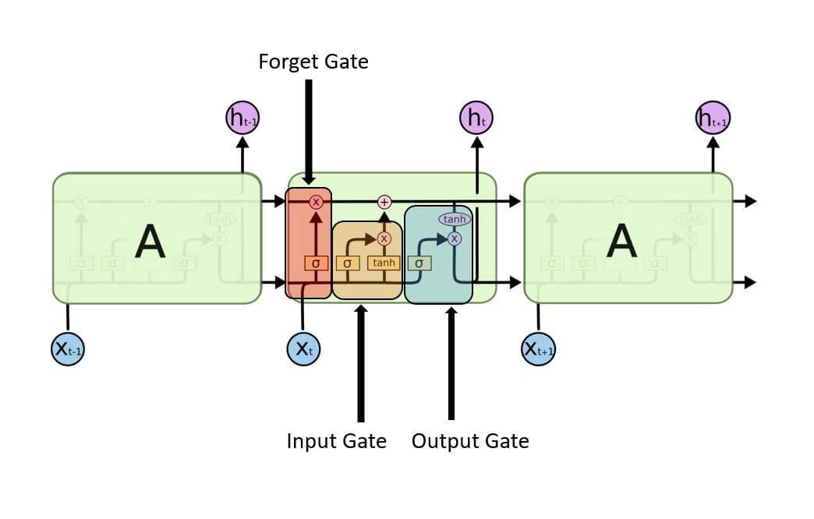

In the literature review, a study by Heidari and Khovalyg (2020) combined LSTM and neural networks for predicting DWH consumption. This project opts for LSTM networks due to their outstanding capability to handle sequential data and recognize long-term dependencies, which are vital for accurate gas consumption prediction. Gas consumption often shows seasonal fluctuations and temporal trends, necessitating precise modelling. The LSTM's proficiency in retaining information for extended periods improves the accuracy and dependability of predictions, especially for space and water heating applications. This ability to capture complex temporal patterns makes LSTM networks particularly effective for this purpose, ensuring strong performance across various predictive and analytical scenarios.

## Evaluation metrics

The evaluation of model performance is essential to compare which model is best for the use of prediction of space and water heating gas usage. According to literature review the main metrics used by Maltais and Gosselin (2021) and Heidari and Khovalyg (2020) and are, Mean Squared Error MSE, Root mean squared error RMSE, R-squared Mean Absolute Error MAE and Mean Absolute Percentage Error MAPE, these evaluation metrics are used by

Where:

$$ŷ_{i}:predicted value$$

$y_{i}:acual value$

$\bar{y}:mean value$

**Error $e_{i}=ŷ_{i}-y_{i}$**

**Mean squared error (MSE)**

The mean squared error Is used to evaluate the accuracy of a model by measuring the average squared difference between the actual and predicted values, a lower MSR shows that the model has a good fit for the data.

**Root mean squared error (RMSE)**

The function of RMSE is the same as MSE however RMSE converts the MSE metric to the same unit as the original making it more interpretable

**R-Squared (R2)**







The R-squared measured the indicates the proportion of the variance in the dependent variable that is predictable from the independent variables in a regression model. It is a key metric for assessing the goodness-of-fit of a model.

And the adjusted R-Squared is modified version of R-squared that adjusts for the number of predictors in the model. The higher the adjusted R-Square means a better fit of the model to the data.

When comparing the if the adjusted R-Squared is lower than R-Squared, it indicates that many predictors in the model are nor contributing to its explanatory power and may be causing overfitting.

**Mean Absolute Error (MAE)**

The MAE is used to measure the accuracy of the prediction from the model, a low MAE suggests that the model's predictions are very close to the actual values, and a high MAE value suggests that the model's predictions are far from the actual values, on average. This indicates that the model is not performing well and has a higher average prediction error.

**Mean Absolute Percentage Error (MAPE)**

The MAPE function is the same as MAE however MAPE expresses the prediction error as a percentage, providing a normalized measure that is easy to interpret and compare across different datasets.

According to Lewis (1982) the evaluation criteria of MAPE is shown in the below Table 4

Table 4: Evaluation criteria of MAPE (Lewis., 1982)

# Model evaluation and Results

To compare the accuracy and fit of the model’s results against actual outcomes, all evaluation metrics were systematically gathered and analysed. These metrics are then compared against one another, as demonstrated in Tables 5, 6, and 7.

## Model Evaluation of the heuristic methods

Table 5: Evaluation metrics for heuristic methods

Table 5 presents the evaluation metrics for heuristic methods, showcasing results across three different models. These models were applied using three distinct methods, each aimed at predicting different types of gas consumption: SH, DWH, and total gas consumption.

**Model 1: A Consistent Struggle with Data Variability**

Model 1 demonstrates poor performance across all categories, failing to capture the data's variability effectively. For total gas consumption, the model's negative R² value of -0.18918 indicates that it does not explain the variability of the response data around its mean. This negative R² value suggests that the model performs worse than a simple horizontal line representing the mean of the observed data. Furthermore, the MAE of 0.035544 and the extraordinarily high MAPE of 202.89% reveal significant prediction errors and substantial percentage deviations from actual values.

The model's performance in predicting SH and DWH is similarly bad. For SH, the R² value of -0.57447 shows the model's inability to explain the variance in the data, with high errors reflected by an MAE of 0.038185 and a MAPE of 112.8889%. The situation is no better for DWH, where the model's R² is -0.57216, and the errors remain high, with an MAE of 0.038177 and a MAPE of 114.3504%. These metrics collectively portray Model 1 as unreliable and inaccurate, making it unsuitable for practical use in predicting gas consumption.

**Model 2: Perfect Fit for Total but Flawed Elsewhere**

Model 2 presents an interesting but concerning scenario. For total gas consumption, it achieves a perfect R² value of 1, accompanied by near-zero errors (MSE: 9.08E-36, RMSE: 3.01E-18, MAE: 6.48E-19, MAPE: 3.63E-15%). At first glance, these results suggest an exceptionally high predictive power. However, such perfect performance is highly unusual in real-world data and often indicates overfitting or data leakage. Overfitting occurs when a model learns the training data too well, including its noise, and fails to generalize to new, unseen data. However, in this case, the cause of this perfect performance is the method used, where SH gas consumption is calculated as actual gas consumption minus DWH gas consumption, leading to predictions that are always accurate when computing evaluation metrics. This method inherently ensures that the actual and predicted values are the same for total gas consumption.

**Model 3: A Balanced Approach**

Model 3 is the most balanced and reliable among the three models. It achieves a moderate R² of 0.20229 for total gas consumption, explaining about 20% of the variance, which, though not high, is a marked improvement over Model 1. With a MAE of 0.027863 and MAPE of 105.6551%, it shows better accuracy and lower prediction errors. For SH, Model 3 excels with a high R² of 0.786923, indicating strong variability capture, and low MAE of 0.01634 and MAPE of 31.84435%, making it superior to Models 1 and 2. In DWH, Model 3 also performs well, with an R² of 0.782964, and the lowest MAE of 0.016347 and MAPE of 30.92273% among the three, solidifying its role as the best choice for benchmarking future methods.

Overall, the three models for the Ratio and Proportions methods show poor evaluation metrics, meaning these models are not reliable for precise predictions. However, they can provide valuable insights into what predictions may look like for the other, and they can still serve as useful benchmarks or starting points for further model development and refinement of potentially more sophisticated models such as linear regression and deep learning.

## Results of the heuristic models

#### Method 1: Estimation Using Temperature and Humidity Ratios

Figure 13: Method 1 predictions

The first method employs temperature and humidity ratios to estimate gas consumption. The Figure 13 illustrates actual gas consumption (blue line) alongside the estimated gas consumption for DWH and SH (orange and green lines, respectively), and the predicted total gas consumption (red line).

This method reveals several key observations. The actual gas consumption demonstrates clear seasonal variations, with higher usage during the winter months and lower usage in the summer. However, the predicted total gas consumption tends to underpredict during the winter and overpredict during the summer. This discrepancy suggests that while the method captures general trends, it fails to fully account for extreme variations in gas usage. Additionally, the estimates for DWH and SH remain relatively stable and consistently lower than actual consumption, indicating a need for better calibration and adjustment to improve accuracy.

#### Method 2 direct substruction

Figure 14: Method 2 total prediction

Figure 15: Method 2 SH and DWH predictions

The second method involves directly subtracting estimated DWH consumption to forecast total gas consumption. This approach is depicted in figures above, where Figure 14 uses solid lines for predicted values and Figure 15 using dotted lines for the predicted total gas consumption.

This method shows improved alignment with actual gas consumption compared to the first method. In the Figure 14 the estimated SH gas consumption (orange line) closely matches the actual consumption during the winter months. However, despite its apparent accuracy, this method may be problematic. By calculating SH gas consumption as the difference between actual gas consumption and DWH gas consumption, the method ensures that the predicted total gas consumption is the same as actual gas consumption as seen in Figure 15. This can be interpreted as extreme overfitting, making the method unreliable for practical use.

#### Method 3 moving threshold

Figure 16: Method 3 predictions

Figure 17: Method 3 Interpolated predictions

**Method 3: Predictions**

The Figure 16 illustrates the actual gas consumption (blue line) compared to the predicted total gas consumption (dotted orange line), along with the estimated values for SH and DWH (green and red lines, respectively).

This method demonstrates several strengths. The high variability in the predicted total gas consumption suggests that the model is highly responsive to changes in consumption patterns. The dotted orange line effectively captures the peaks and troughs of actual gas consumption, particularly during the winter months when gas usage is high and the summer months when it is low. This close alignment indicates the model's strong adaptability to seasonal changes.

Moreover, the detailed estimates for SH and DWH provide valuable insights into specific consumption patterns. The green and red lines enhance the model’s overall accuracy by breaking down total consumption into its components. This level of detail can be particularly useful for targeted interventions and more precise forecasting in specific areas of gas consumption.

**Method 3: Interpolated Predictions**

As shown in Figure 16, numerous predictions are missing, rendering the Figure unusable. To address this issue, interpolation was applied to the predicted data to fill in these gaps. The results of this process are displayed in Figure 17, where the previously missing predictions have been effectively filled, making the data more coherent and usable.

Figure 17 compares the actual gas consumption (blue line) with the interpolated predicted gas consumption (dotted orange line). This method shows an improved fit, and smoother predictions compared to the previous approach.

The interpolated predictions closely follow the actual gas consumption, indicating enhanced accuracy. The dotted orange line aligns more tightly with the blue line, reflecting a more stable and reliable prediction model. This smoothing effect helps to mitigate some of the extreme variations seen in the first prediction method, providing a more consistent forecast that still captures the general trends and seasonal fluctuations.

The strong alignment with actual consumption patterns, particularly during the winter and summer months, underscores the effectiveness of this method in capturing seasonal changes. The interpolation technique balances accuracy and stability, making it a more reliable choice for forecasting gas consumption.

## Model Evaluation of the liner regression and Deep learning

Table 6: Evaluation metrics of linear regression and deep learning

Figure 18: plots of evaluation metrics for table 6

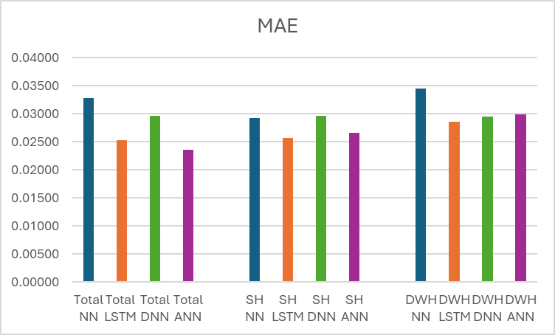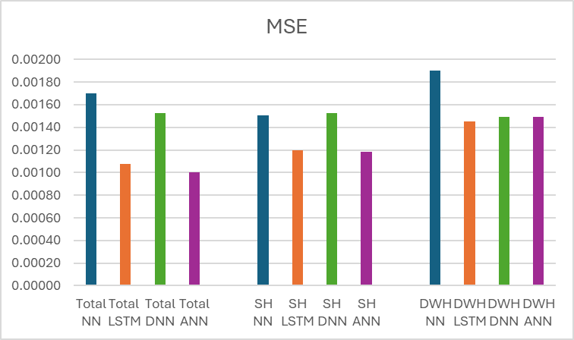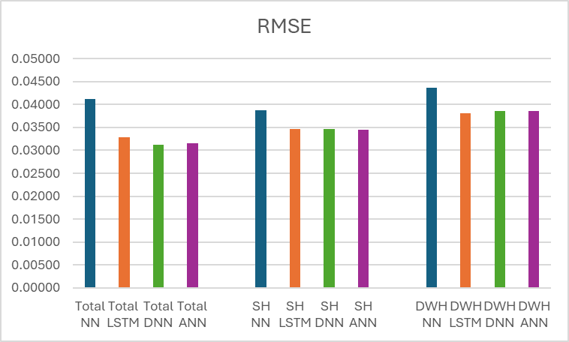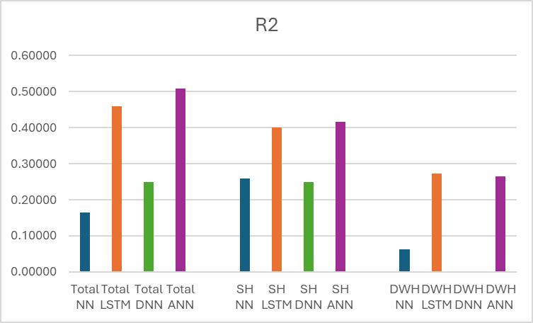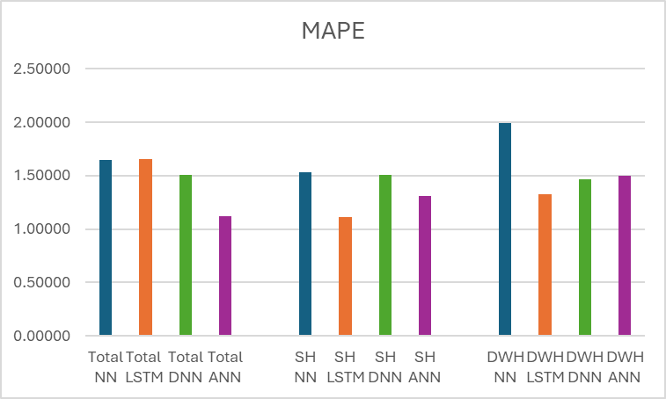

Table 6 and Figure 18 present the evaluation metrics for both the linear regression and deep learning methods. These models were employed to predict three different types of gas consumption: SH, DWH, and total gas consumption. The data used for these predictions consist of actual gas values as the target, with feature values adjusted based on the type of prediction. Specifically, for SH predictions, only SH data is used; for DWH predictions, only DWH data is utilized, and for total gas consumption predictions, both SH and DWH data are included. This approach ensures that each model is tailored to the specific characteristics of the data it is predicting.

**Linear Regression**

Linear Regression performs the worst among all models for total gas consumption, SH, and DWH gas consumption, with a low MAE of 0.11-0.13 and a MAPE of 1.84% - 2.12%. These low MAE and MAPE values indicate that the predictions are closer to the actual values, suggesting higher accuracy. The model's MSE of 0.021-0.0266 and RMSE of 0.14511-0.163 are quite low, further demonstrating that the model's predictions are close to the actual values. The model for total gas consumption has a relatively high R² value of 0.40336, indicating that a substantial proportion of the variance in the dependent variable is explained by the model, suggesting a decent fit. However, for SH, the R² value is 0.31544, and for DWH, the R² value is 0.24611, both of which are quite low, indicating poor fits. Therefore, the Linear Regression method is unsuitable for predictions in these cases due to its low R² values. Nonetheless, the linear regression results can be used as a baseline for developing more sophisticated deep learning models.

**Artificial Neural Network**

The ANN model shows strong performance in predicting total gas consumption, SH, and DWH gas consumption, significantly outperforming the baseline Linear Regression model. For total gas consumption, SH, and DWH, ANN demonstrates lower error metrics with a MAE ranging from 0.02361 to 0.02984 and a MAPE from 1.11665% to 1.50131%, indicating higher accuracy. The MSE ranges from 0.00100 to 0.00149 and RMSE from 0.03162 to 0.03864, reflecting precise predictions. The R² values range from 0.26459 to 0.50745, indicating moderate to good explanatory power, significantly better than Linear Regression’s R² values of 0.24611 to 0.40336. Overall, ANN’s performance across all categories suggests it is a highly suitable model for gas consumption forecasting, providing lower error metrics and greater accuracy compared to the baseline Linear Regression model. For total gas consumption, ANN’s metrics show high accuracy and precision, making it effective for forecasting. For SH, ANN maintains robustness with good explanatory power and relatively accurate predictions. In predicting DWH, ANN shows moderate performance, indicating it can provide useful predictions but may benefit from further tuning or complementary methods to enhance accuracy.

Therefore, based on the combination of all these metrics, the ANN model is the best model for this dataset due to its superior performance across most evaluation metrics.

**DNN,NN,and LSTM**

The DNN method shows only slight improvements over the baseline Linear Regression model for predicting total gas consumption, SH , and DWH , with marginally better MAE (0.02954 to 0.02967) and MAPE (1.46283% to 1.50914%) but low R² values (0.24936 for total consumption and SH, 0 for DWH), indicating limited explanatory power. In contrast, the NN model performs worst among all models, with higher error metrics and the lowest R² values (0.06324 to 0.25896), showing it is less reliable for forecasting. However, the (LSTM) model outperforms both DNN and Linear Regression, achieving lower error metrics (MAE of 0.02533 to 0.02852, MAPE of 1.10808% to 1.65186%), better MSE and RMSE values, and higher R² (0.27299 to 0.45945), making it the most suitable for accurately predicting gas consumption.

## Results of linear regression and neural network models

### Linear regression

Figure 19: Linear regression prediction

The predicted values (orange line) generally follow the overall trend of the actual values (blue line), but there are notable discrepancies at various points. During the winter months, when gas consumption is high, the model tends to underpredict, with the orange line consistently below the blue line. In contrast, during the summer months, when gas consumption is low, the model often overpredicts, with the orange line frequently above the blue line. This indicates that the model doesn't fully capture the variability in actual gas consumption, as shown by the higher fluctuations in the blue line compared to the smoother orange line. Overall, the model captures the general trend and seasonality reasonably well but struggles to accurately predict the exact values, especially during periods of extreme consumption.

### Artificial neural network ANN

To estimate total gas consumption, the feature data can include both SH and DWH temperature and humidity data. When estimating specific gas consumption for either SH or DWH, the feature data should be limited to the corresponding SH or DWH variables, ensuring that only the relevant data is used for each specific prediction.

Figure 20: Epoch of ANN for SH, DWH and total

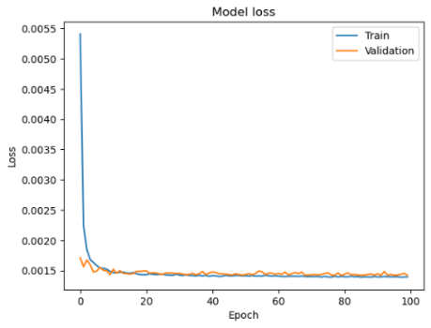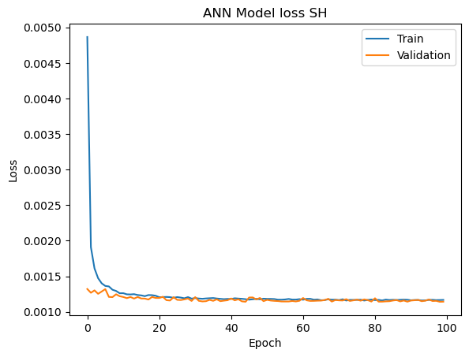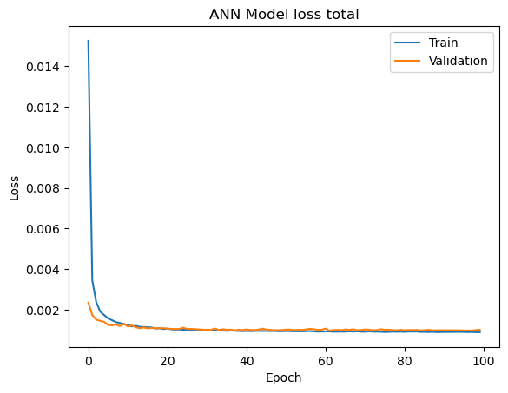

The Figure 20 above offer insights into the performance of the ANN model over 100 epochs, with loss values plotted for both the training and validation sets. The vertical axis represents the loss value, indicating the model's prediction error, while the horizontal axis denotes the number of epochs, each representing a complete pass through the training dataset. Observing the blue line for training loss and the orange line for validation loss, it is evident that both curves exhibit a rapid decrease in loss within the initial epochs, suggesting that the model is learning quickly and effectively reducing error. After about 20 epochs, the loss values stabilize and maintain low levels, indicating that the model is not overfitting, as evidenced by the validation loss not increasing significantly over time. Moreover, the close tracking of the validation loss with the training loss demonstrates that the model is generalizing well to unseen data. The absence of significant divergence between the two curves further underscores the model's robustness. Overall, the graph reflects a well-trained ANN model that effectively learns from the data and generalizes its predictions, showcasing strong performance and reliability.

#### Total Gas Consumption

The Figure 22 shows the actual versus ANN-predicted total gas consumption reveals several critical aspects of the model's performance. The blue dots, representing actual gas consumption, and the orange dots, indicating the predicted values by the ANN model, generally follow the same trend. This alignment suggests that the ANN model can capture the patterns in total gas consumption. However, up on a closer inspection of the data in Figure 21 reveals a significant degree of scatter. The predicted values often deviate from the actual values, indicating prediction inaccuracies. This variability highlights the need for further refinement of the model to enhance its precision and reduce prediction errors.

Figure 21:ANN hourly total prediction on training data

Figure 22:ANN hourly total prediction

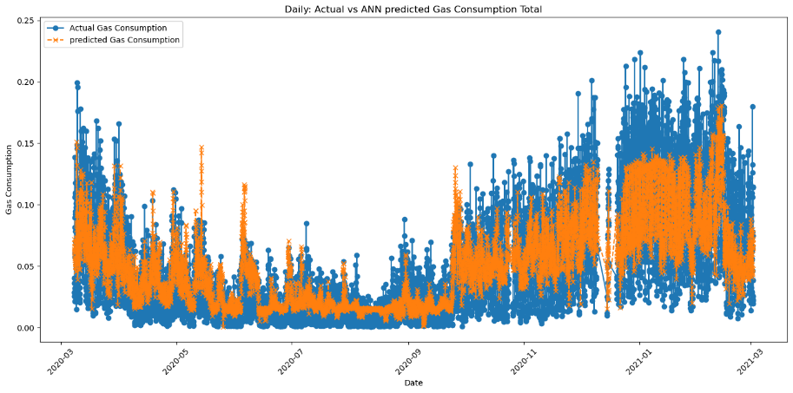

#### Space Heating

For SH, the ANN model continues to perform reasonably well but with some significant errors. The Figure 23 shows a similar pattern to Figure 22 where the model's predictions follow the trend of the actual values (blue dots). However, there are notable instances where the predicted values significantly deviate from the actual values, indicating that the model's accuracy could be improved. This discrepancy is particularly evident during the winter months from November to February, where SH predictions differ markedly from the actual gas consumption. Although this variation might be influenced by increased DWH usage, which raises total gas consumption, the overall pattern as seen in the Figures 19 and Figures 22, suggests that SH gas consumption is expected to increase more than the current model predicts. This inconsistency highlights the need for further optimization to enhance the model's accuracy in forecasting SH consumption.

Figure 23: ANN hourly SH prediction

#### Domestic Water Heating

Predicting gas consumption for DWH is where the ANN model faces the most challenges. The Figure 24 DWH shows that the model’s predictions are less reliable with some predictions typically in the spring months of march to June where predictions rise above the actual gas consumptions despite Figure 13 and 17 may suggest that DWH usage should be relatively consistent and Figure 5 showing that indoor temperature does not drop, and outdoor temperature are significantly lower than indoor temperature suggesting that DWH usage should not be as high. This level of error suggests that the model struggles to capture the unique patterns associated with DWH consumption. One of the reasons for this difficulty is the variability in human behaviour, as DWH is primarily used for showering. The timing and duration of showers can be highly uncertain, and change based on the occupants' habits and behaviours. These factors introduce a level of unpredictability that the ANN model currently fails to account for. It indicates that the ANN might need more sophisticated adjustments or even additional data to improve its performance in this specific area. Enhanced models could incorporate behavioural data or employ more advanced techniques to better capture the irregular patterns of DWH consumption.

Figure 24: ANN hourly DWH prediction

## Model evaluation of Hourly vs daily

As mentioned above it can be inferred that the hourly data may increase the error for predictions of SH and DWH gas usage, in which case by aggregating the data from hourly to daily will reduce noise and variability in temperature and humidity for SH and DWH rooms, leading to smoother input for the model and decreases reducing model complexity which can increase prediction accuracy.

The ANN model used for prediction with daily data have been set to 20 epoch as seen in Figure 25 because in the hourly ANN model seen in Figure 20 the epoch was 100 and loss values stabilize and maintain low levels after epoch of 20, indicating that the model will not be overfit by setting the daily model’s epoch to 20 this will reduce computation time.

Figure 25: ANN daily epoch

Table 7: Evaluation metrics of hourly and daily

The results of the daily ANN model, as presented in Table 7, show an R² value of 0.6471 for total gas consumption, 0.7937 for SH, and 0.6286 for DWH. When compared with the hourly prediction model, the R² value of 0.4154 for SH and 0.2646 for DWH are significantly lower, indicating that the daily model performs significantly better in terms of predictive accuracy. Furthermore, the MAPE for the daily model is around 0.4 for both SH and DWH, whereas the hourly model's MAPE exceeds 1, suggesting that the daily model has a lower prediction error overall.

Other evaluation metrics, such as the MAE, MSE, and RMSE, do not show significant differences between the daily and hourly models, indicating comparable performance across these measures. This suggests that while both models perform similarly on some metrics, the daily model generally provides more accurate and reliable predictions for SH and DWH, making it a preferable choice for applications requiring lower error rates.

## Results of daily ANN model

Figures 26, 27, and 28 illustrate a comparison between actual gas consumption and predictions made by ANN models for different heating applications: total gas consumption (Figure 26), SH (Figure 27), and DWH (Figure 28). Each figure illustrates the effectiveness of the ANN models in capturing daily gas consumption trends over a one-year period from March 2020 to March 2021.

Figure 26: ANN daily prediction total

Figure 27: ANN daily prediction SH

Figures 26 and 27 illustrate the performance of ANN models in predicting gas consumption for total usage and SH, respectively, showing that both actual and predicted values exhibit seasonal variations, with higher consumption from October to March and lower consumption from April to September. The two models, effectively captures increased gas usage during colder months. However, both similarly captures minor discrepancy during peak winter demand, where predictions occasionally underestimate actual consumption spikes, and during warmer months, where overestimations occur. For SH specifically, there tends to be more under fitting during the warmer months of June to November.

Figure 28: ANN daily prediction DWH

In contrast to Figures 26 and 27, Figure 28, which displays predictions for DWH, reveals more significant inaccuracies. During the spring months from March to June, the predicted gas consumption notably exceeds the actual values, reflecting substantial overestimation. This pattern of overestimation is consistently seen across both the warmer spring and early summer periods. Such overestimation suggests that the ANN model struggles to account for the lower and more stable demand typically associated with DWH during these months when outdoor temperatures are milder, and the need for extensive water heating is reduced.

# Conclusion and Future works

**Conclusion**

In this project, various methods were explored to estimate the split of gas consumption into SH and DWH. These methods included heuristic approaches, linear regression models, and deep learning models. After comparing the performance of these different approaches, the ANN deep learning model was found to provide the most favourable evaluation metrics, demonstrating its effectiveness for this task.

The ANN model demonstrated stronger predictive capabilities, especially when applied to data aggregated to a daily basis compared to one on that is hourly. This approach led to high R² values, indicating its effectiveness in accurately estimating total gas consumption. Despite these high R² values and other favourable evaluation metrics, such as low MSE and MAE, the daily model has limitations. It struggles to distinctly differentiate between SH and DWH consumption.

This limitation suggests that while the daily model is effective for predicting total gas consumption, it may not be as suitable for capturing the distinct patterns associated with each type of heating. Consequently, the daily model may not be as effective or useful as the hourly model for making predictions, particularly when the goal is to distinguish the split between SH and DWH types of gas consumption. This observation points to a potential area for further refinement and improvement of the model to enhance its accuracy and applicability.

**Future Work**

Future improvements could be made by incorporating more feature data into the deep learning models, such as solar irradiation and wind speed. These additional environmental factors could provide more context for understanding variations in gas consumption, potentially leading to more accurate predictions. Including these features could help the model account for the influence of weather conditions on heating demand.

Another area for future development is to consider heat transfer within buildings. For example, modelling the difference in temperature between the ground floor and upper floors could improve accuracy, as upper floors tend to be hotter due to heat rising. Incorporating this aspect of internal heat dynamics would allow the model to better reflect real-world conditions.

Furthermore, using individual data from 30 households instead of a combined aggregate data to predict gas consumption could be used as another method of future research, by exploring the split predictions of SH and DWH for individual households and clustering them. This approach could provide more tailored insights and improve the precision of the model by accounting for the specific characteristics and usage patterns of each household.

# References

Alzaatreh, A., Mahdjoubi, L., Gething, B. and Sierra, F., (2018). Disaggregating high-resolution gas metering data using pattern recognition. *Energy Buildings*, 176, pp.17-32. Available at: https://doi.org/10.1016/j.enbuild.2018.07.011.

Analytics Vidhya, (2022). An overview on Long Short-Term Memory (LSTM). *Analytics Vidhya*. Available at: https://www.analyticsvidhya.com/blog/2022/03/an-overview-on-long-short-term-memory-lstm/ [Accessed 22 August 2024].

Andrieu, M., (2019). Applied deep learning - Part 1: Artificial neural networks. *Towards Data Science*. Available at: https://towardsdatascience.com/applied-deep-learning-part-1-artificial-neural-networks-d7834f67a4f6 [Accessed 22 August 2024].

Bacher, P., de Saint-Aubain, P.A., Christiansen, L.E. and Madsen, H., (2016). Non-parametric method for separating domestic hot water heating spikes and space heating. *Energy Buildings*, 130, pp.107-112. Available at: https://doi.org/10.1016/j.enbuild.2016.08.037.

DBEIS, (2018). What is a heat network?. [pdf] Available at: https://assets.publishing.service.gov.uk/media/5abccf5f40f0b6026d7ecefb/HNIP_What_is_a_heat_network.pdf [Accessed 20 August 2024].

DBEIS, (2021). Heat and Buildings Strategy. [online] Available at: https://www.gov.uk/government/publications/heat-and-buildings-strategy/heat-and-building-strategy-accessible-webpage#chapter-5-reducing-emissions-in-the-2020s [Accessed 20 August 2024].

Department for Energy Security & Net Zero, (2024). 2023 UK greenhouse gas emissions, provisional figures. [pdf] London: Department for Energy Security & Net Zero. Available at: https://assets.publishing.service.gov.uk/media/6604460f91a320001a82b0fd/uk-greenhouse-gas-emissions-provisional-figures-statistical-release-2023.pdf [Accessed 20 August 2024].

DESNZ, (2024). 2023 UK greenhouse gas emissions, provisional figures. [pdf] London: Department for Energy Security and Net Zero. Available at: https://assets.publishing.service.gov.uk/media/6604460f91a320001a82b0fd/uk-greenhouse-gas-emissions-provisional-figures-statistical-release-2023.pdf [Accessed 20 August 2024].

GOV.UK, (2023a). Net zero government emissions roadmap. [pdf] Available at: https://assets.publishing.service.gov.uk/media/6569cb331104cf000dfa7352/net-zero-government-emissions-roadmap.pdf [Accessed 20 August 2024].

GOV.UK, (2023b). Solar thermal TIL - April 2020. [pdf] Available at: https://assets.publishing.service.gov.uk/media/65dc416287005a1daa80f83a/Solar_Thermal_TIL_-_April_2020.pdf [Accessed 20 August 2024].

Heidari, A. and Khovalyg, D., (2020). Short-term energy use prediction of solar-assisted water heating system: Application case of combined attention-based LSTM and time-series decomposition. *Solar Energy*, 207, pp.626-639. Available at: https://doi.org/10.1016/j.solener.2020.07.008.

Ivanko, D., Sørensen, Å.L. and Nord, N., (2021). Splitting measurements of the total heat demand in a hotel into domestic hot water and space heating heat use. *Energy*, 219, Article 119685. Available at: https://doi.org/10.1016/j.energy.2020.119685.

Lewis, C., (1982). Industrial and business forecasting methods. London: Butterworth Scientific, p.p40.

Leiria, D., Johra, H., Marszal-Pomianowska, A. and Pomianowski, M.Z., (2023). A methodology to estimate space heating and domestic hot water energy demand profile in residential buildings from low-resolution heat meter data. *Energy*, 263(Part B), 125705. Available at: https://doi.org/10.1016/j.energy.2022.125705.

Li, X. and Yao, R., (2020). A machine-learning-based approach to predict residential annual space heating and cooling loads considering occupant behaviour. *Energy*, 212, 118676. Available at: <https://doi.org/10.1016/j.energy.2020.118676>.

Maltais, L.-G. and Gosselin, L., (2021). Predictability analysis of domestic hot water consumption with neural networks: From single units to large residential buildings. *Energy*, 229, 120658. Available at: https://doi.org/10.1016/j.energy.2021.120658.

Pomianowska, M., A., Zhang, C., Pomianowski, M., Heiselberg, P., Gram-Hanssen, K. and Hansen, A.R., (2019). Simple methodology to estimate the mean hourly and the daily profiles of domestic hot water demand from hourly total heating readings. *Energy Buildings*, 184, pp.53-64. Available at: <https://doi.org/10.1016/j.enbuild.2018.11.035>.

Python Software Foundation, (n.d.). Python Programming Language. Version 3.7. Available at: http://www.python.org.

Scikit-learn, (n.d.). MLPRegressor. [online] Available at: https://scikit-learn.org/stable/modules/generated/sklearn.neural_network.MLPRegressor.html [Accessed: 23 August 2024].

Umishio, W., Ikaga, T., Fujino, Y., Ando, S., Kubo, T., Nakajima, Y., Kagi, N., Hoshi, T., Suzuki, M., Kario, K., Yoshimura, T., Yoshino, H. and Murakami, S., (2024). Spatial and temporal indoor temperature differences at home and perceived coldness in winter: A cross-sectional analysis of the nationwide Smart Wellness Housing survey in Japan. *Environment International*, 186, 108630. Available at: https://doi.org/10.1016/j.envint.2024.108630.

uSwitch, (2023). Smart meter statistics. [online] Available at: https://www.uswitch.com/gas-electricity/studies/smart-meter-statistics/#:~:text=At%20the%20end%20of%20September,first%20rolled%20out%20in%202008 [Accessed 20 August 2024].

World Health Organization, (2018). WHO Housing and Health Guidelines. World Health Organization. Available at: https://iris.who.int/bitstream/handle/10665/276001/9789241550376-eng.pdf [Accessed: 23 August 2024].

# Appendix

**Step A6 – MSC ESDA Dissertation Ethics Declaration**

|  |
| --- |
| **Statement of Risk Assessment & Ethics Approval** **Requirements** |
| **Student Candidate Number** [HZYC1]:  Student Name: [HAOCHEN SHI]:  Student UCL Email Address: [UCBVHS2@UCL.AC.UK]:  **Supervisor Name:** [ Frances Hollick]:  Supervisor UCL Email Address: [frances.hollick.15@ucl.ac.uk]:  **Dissertation Research Proposal** [FILL IN]:   * Title / Topic: Developing a method to estimate the split of gas consumption into space and water heating * Research Question(s) / Aims & Objectives: Derive a model for splitting gas consumption data into that used for space and water heating based on other datastreams such as relative humidity. A dataset of 15 homes is available for this. * Data & source (specify all data to be used; if none, explain why): <https://reshare.ukdataservice.ac.uk/855894/> The dataset comprises gas and electricity consumption, indoor air temperature, and indoor relative humidity measured in 15 different dwellings. * Method(s) (specify all methods to be used):   Data processing  Quantitative data analysis  Comparative analysis  Descriptive statistics  Literature review and contextual analysis  Data visualisation  Create different DL models |
| I have read and understood **Step A1 ‘Does the research require a Risk Assessment?’** and:   * This planned research does NOT require a risk assessment. |
| I have read and understood **Step A2 ‘Does the research require External research ethics approval?’** and:   * This planned research does NOT require external ethics review. |
| External ethics approval is *not required* and I have read and understood **Step A3 ‘Is the research Exempt from the need for ethics approval?’** and:   * This planned research IS EXEMPT from the need for research ethics approval.   . |
| The research is *not exempt* from the need for ethics approval and I have read and understood **Step A4 ‘Does the research require High Risk ethics approval?’** and:   * This planned research is NOT deemed high risk. |
| The research is *not exempt* from the need for ethics approval, does not require high risk ethics approval and: I have read and understood **Step A5 ‘Does the research require ESDA low risk ethics review for questions-based methods OR BSEER low risk ethics review for other methods?’** and:  [DELETE ONE STATEMENT]:   * This planned research requires BSEER low risk ethics approval (for other methods), which will be secured before data collection starts. |
| **I confirm that:**   * the information I have provided is accurate to the best of my knowledge. * if the answers to any of these questions changes, I will go through this protocol again. |

**NEXT STEPS:**

* **STUDENT:** Copythe text of the *completed*statement above into an email and email it to your supervisor.
* **SUPERVISOR: Reply to the email confirming your approval of the completed statement, copying the Dissertation PGTA (**[**r.alasmar@ucl.ac.uk**](mailto:r.alasmar@ucl.ac.uk)**). It is the student’s responsibility to ensure that happens.**
* **STUDENT:**
  + Include this A6 Statement as a Dissertation Appendix after you have BLACKED OUT YOUR NAME & EMAIL ADDRESS so the second marker can mark anonymously.

The Dissertation mark sheet asks the second marker whether this form was filled out correctly and, if not, what % mark deduction they recommend.